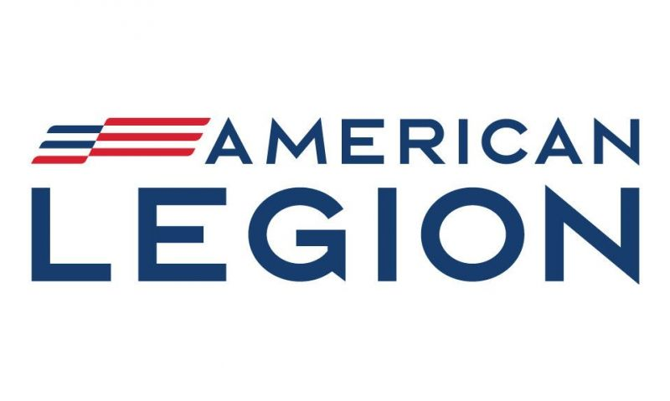
THE AMERICAN LEGION
DEPARTMENT OF NEW YORK

LEGISLATIVE
AGENDA

Serving America and its veterans for over 100 years.
Updated May 2026
The American Legion Department of New York family is the voice of over 200,00 veterans, service members, and their families. As a resolutions-based organization, the American Legion’s positions represent the views of its members. They are based on the four pillars: Veterans Affairs & Rehabilitation, National Security, Americanism, and Children & Youth.

John Miga
Department Commander
James W. Casey
Department Adjutant
Lee Hinkleman
Department Legislative Chairman/ National Vice Chairman
Francis A. LaMarsh
Legislative Advisor
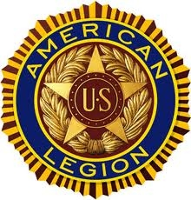
The American Legion
Department of New York
1304 Park Boulevard
Troy, New York 12180
518-463-2215
www.nylegion.net

1. Be the One” Campaign. Today, the No. 1 issue facing the veteran community is suicide, according to the National Veteran Suicide Prevention Annual Report. Approximately 17 - 22 veterans or servicemembers take their lives daily. That’s more than 6,000 annually. The rate of suicide for veterans is more than 50% higher than that of non-veteran adults. As the Global War on Terrorism continues, more veterans will face mental health issues like post-traumatic stress disorder. At its core, The American Legion is activating a national platform to reduce the rate of veteran suicide. The Be the One campaign will:
- Destigmatize asking for mental health support by creating opportunities for those with mental health issues to speak freely and get the help they need.
- Provide peer-to-peer support and resources in local communities.
- Deploy FDA-approved therapeutics for veterans to identify issues and find resources for support.
We urge the New York State Legislature and state agencies to raise awareness and maintain funding for programs and groups dedicated to supporting veterans and their families.
The American Legion supports Senate Bill S7129, which relates to veterans’ health care and suicide prevention.
2. Boys State (American Legion) / Girls State (American Legion Auxiliary) The leaders of tomorrow are not simply born, they are molded by the experiences of their youth, which change and inspire them. One of the biggest impacts on the next generation is programs that teach high school students leadership skills and an understanding of the world around them. Two such programs are the American Legion Boys’ State and American Legion Auxiliary Girls’ State. Previously, the state has awarded Boys’ State $150,000.
New York Boys’ and Girls State hosts up to 1,000 high school juniors for its week-long program at SUNY in Morrisville, and Girls State takes place at SUNY in Brockport. These young men and women learn the importance of the individual in all levels of government and the effect one person has on the character and success of the community. Several current Senators and Assembly members are alumni.
We urge the New York State Legislature and the appropriate state agency to create a line item for $250,000 ($200,000 for Boys State/ $50,000 for Girls State) annually to support the American Legion Boys State and Girls State program.
4. USS Turner Resolution: The American Legion Department of New York urges action be taken to identify the remains of the crewmen killed aboard the USS Turner that exploded and sank on January 3rd, 1944, outside New York harbor, killing 136 crewmen. The Defense POW/MIA Accounting Agency (DPAA) states that without an Xfile, a file that documents the circumstances of the recovery of the remains and other pertinent information, building a case for disinterment is difficult. Letter dated Aug 6, 2019, from Defense POW/MIA Accounting Agency: “Therefore, DPAA scientific staff have no means of comparing biological profile information to determine which of the 136 missing Sailors from USS Turner are associated with the Unknowns. While DPAA lacks the required evidence to request disinterment of the four graves, we continue to look for innovative ways to pursue disinterment and fulfill current DoD policies.”

The American Legion Department of New York requests that the Governor and the State Legislature take immediate action to establish a commission to assist in the identification of these fallen heroes. We are also working closely with Senator Schumer's office at the Federal Level.

4. Electronic Bell Jar Vending Machine Legislation:

The bill was signed by the Governor on 12.19.25. The law takes effect one year from passage. No machines are permitted in tribal gaming exclusion zones, except potentially in the Oneida region, as charitable gaming is excluded under settlement documents. Next steps are to engage with the Gaming Commission in support of drafting the rules and regulations that will govern the program during the one-year wait. This could result in a program kickoff in the fourth quarter of 2026. We encourage our elected officials and members to engage the Gaming Commission.

The following are some other bills making their way through the halls of Albany:
NY Senate Bill S00180 from the 2020-2021 legislative session directed the Veterans Service Commission to submit a report regarding the coordination of services for veterans with service-connected disabilities. This bill was prefilled for the 2021-2022 session, not the current session. The bill needs to be reintroduced.
NY Senate Bill S910A (2025-2026 Session) Establishes a tax credit for businesses that hire Veterans and disabled veterans. The bill provides a $3,000 credit for each veteran hired and a $4,000 credit for each disabled Veteran, with a total annual benefit cap of $15,000 per employer, currently in the Senate Budget and Revenue Committee.
NY Assembly Bill A07520 (2025-2026 session) proposes to amend the veterans service law to expand the definition of “veteran”. It includes members of the Army/Air National Guard, the New York Guard, and the naval militia with at least 20 years of service, of which at least 5 were during wartime or hostilities, in the Veterans Affairs Committee.
Gold Star Families (2026) Proposed legislation (A06934) aims to provide state-paid health insurance and cover educational costs (up to post-graduate), and housing assistance to Gold Star family members, in the Assembly on Veteran Affairs.
As of February 2026, New York State has enacted a mandatory statewide full property tax exemption for honorably discharged veterans with a 100% service-connect disability rating (or individual unemployability) on their primary residence. This exemption, stemming from legislation, applies to county, city, town, village, and school district taxes. The problem is that once you are eligible for IU (individual unemployability), you are not eligible for 100 % disability. So no one would qualify for this in New York State. Chapter 77 of the laws of 2026 needs to be amended.
We desperately need 4 minutes of your time. Go to legion.org/action to support our National Legislative issues.

