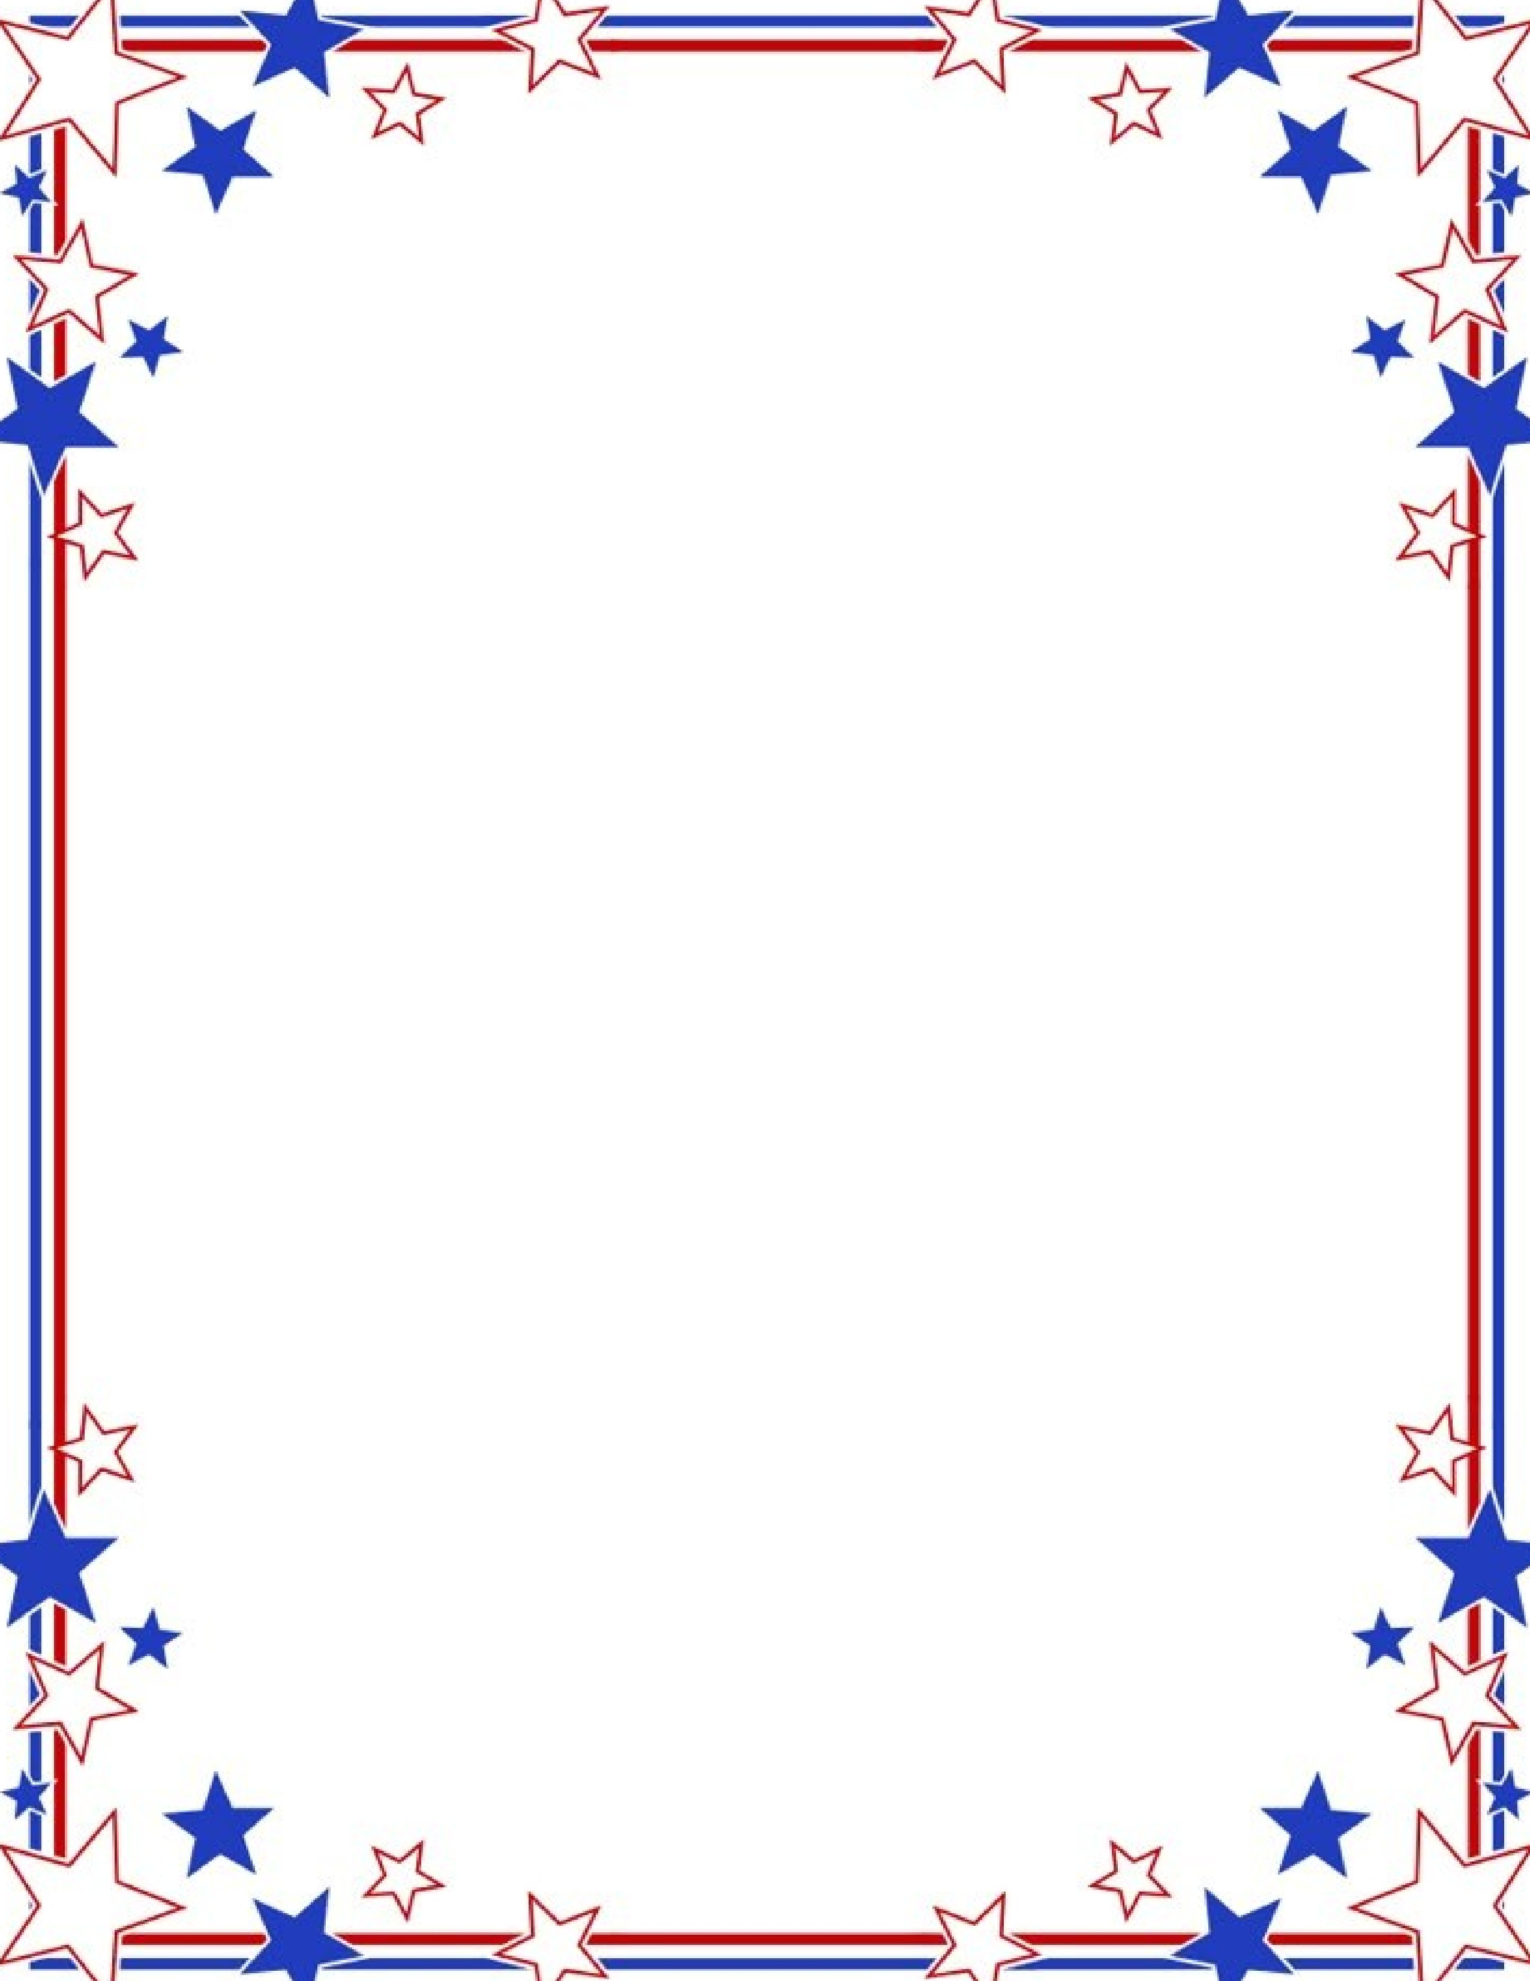
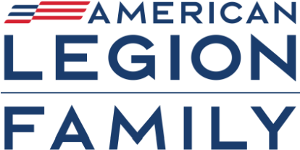

Department of New York

American Legion Family Homecoming

Vernon Downs Casino Hotel

4229
Stuhlman Rd, Vernon, NY 13476

A block of rooms has been reserved for your convenience.

Use Code:
“
American Legion Homecoming”

$119.00/night

{Bring Tax Exempt form}

Call: (315) 829-3400

ROOM RESERVATION DEADLINE: APRIL 30, 2026

Dinner
$65.00 per person

Social Hour 5 p.m. on Outdoor Terrace w/Cash Bar

Dinner 6 p.m.

Dinner Reservation Deadline May 9, 2026

American Legion Commander John R. Miga

Auxiliary President Maureen Morgan

Detachment Commander Joseph Guidice, Jr.
Saturday, May 30, 2026

Things to do: Horse Racing & Casino - Free admission to Live Bands in Casino on Fri. & Sat. evening

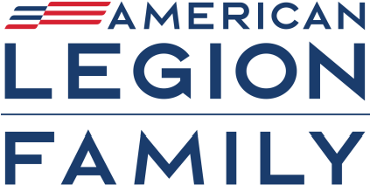

Department of New York

American Legion Family Homecoming
American Legion Commander John R. Miga
Auxiliary President Maureen Morgan
Detachment Commander Joseph Guidice, Jr. Saturday, May 30, 2026 Vernon Downs Casino Hotel
For more information: Please call or text 716-680-0425 or email: ajmiga@yahoo.com

DINNER RESERVATION
Please complete and return by May 9, 2026
Presale meals only No cancellations
$65.00 per person
Please make checks payable to: John Miga Mail to: Audrey Miga, 188 E. Pine St., Dunkirk, NY 14048
Meal Selection (indicate quantity)
______ Filet Mignon on Crostini w/Mushroom Demi-Glace, garlic mashed potato, vegetable
______ Chicken Francese, garlic mashed potato, vegetable
______ Baked Haddock w/crab stuffing & garlic butter sauce, garlic mashed potato, vegetable
______ Vegetable Pasta Puttanesca
Includes: Salad, Rolls, Dessert, Coffee, Tea
Name(s): ___________________________________________________________________
____________________________________________________________________________
Phone Number: ___________________________________________________________

Amount Enclosed: _________________________________

