2021
National Historian’s Luncheon
102nd National Convention
Phoenix, Arizona

The National Historian’s Luncheon will be Saturday, August 28, from 11:30 am to 1:30 pm. Location to be determined.

Menu for the luncheon: Starting with Greek Salad: Mediterranean greens, European cucumber, heirloom tomatoes, Kalamata olives, barrel aged feta and white balsamic dressing. Main Entrée: Mediterranean Chicken: Lemon scented breast of chicken with artichoke, tomato, olive, feta ragout, roasted red pepper, sauteed asparagus and roasted marble potatoes. Ending with a Dessert of Chocolate pecan tart with dark fudge and caramel sauce.

Cost of the meal is $44.00 (Includes all gratuity and taxes).

Current and Past Department Historians, members of NADHAL, and other Legion Family members are invited to attend. Please return the portion below with check payable to James Mariner, National Historian by August 6, 2021 to save your reservation (Reservations are not secured until payment is confirmed). Seating is limited and tickets will not be sold on-site. Tickets sold prior to August 6 will be distributed at the venue.

Our guest speakers will be PNC Denise Rohan and Cathy M. Taylor, Archivist at The American Legion Auxiliary Headquarters in Indianapolis, Indiana. Cathy will speak on American Legion Auxiliary’s (ALA) 100th Anniversary. Cathy will be bringing her 91-year-old mother with her. PNC Rohan will be speaking on her experiences as the first female American Legion National Commander

After the luncheon and guest speaker/s we will hold a brief meeting of our National Association of Department Historians of The American Legion (NADHAL).
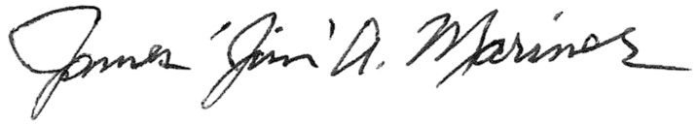
James “Jim” A. Mariner
National Historian
---------------------------------------Reservation -- Detach And Return--------------------------------------------

Mail To: James Mariner, 1899 Pacheco St., Apt 2211, Santa Fe, NM, 87505. Phone: 505-670-1255

I will be attending the National Historian’s Luncheon. The party or guests will include a total of ____ person(s) at $44.00 each. My check in the amount of $__________ is enclosed with this reservation. “Reservations are not secured until payment is confirmed.”

Name:______________________________________ Department_____________________

Guest: ______________________________________ Department ___________________

Guest: ______________________________________ Department ___________________

