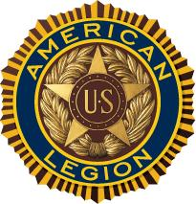
The American Legion
Department of New York
100th Annual Mid-Winter Conference
Reception & Dinner Reservation Form
Enclosed is my check payable to:
The American Legion, Department of New York
In the amount of $________ for ________ ticket(s) at $45.00 each
for the 100th Annual Mid-Winter Conference Reception & Dinner
on Saturday January 26th, 2019
Name:______________________________________________
Email:_________________________
Phone #_______________________
County:________________________ District:___________
Mail this form with checks to:
The American Legion- Department of New York
112 State Street
Suite 1300
Albany, NY 12207

Note: All Tickets can be picked up at the Registration Table at the Conference.

Tickets must be picked up BEFORE 3:00 p.m. on Saturday January 26th, 2019

