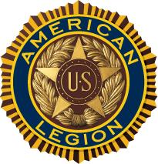
The American Legion
Department of New York
99th Annual Mid-Winter Conference
Reception & Dinner Reservation Form
Enclosed is my check payable to:
The American Legion, Department of New York
In the amount of $________ for ________ Ticket(s) at $35.00 each

for the 99th Annual Mid-Winter Conference Reception & Dinner
on Saturday, January 20th, 2018
Name:____________________________________________
Email:_________________________
County:________________________ District:_______________
Mail this form with checks to:
The American Legion- Department of New York
112 State Street
Suite 1300
Albany, NY 12207

Note: All Tickets can be picked up at the Registration Table at the Conference.

Tickets must be picked up BEFORE 3:00 p.m. on Saturday, January 20th, 2018

